

Procedures Onboarding System

Introduction

This document outlines the implementation of a system to manage the metadata of procedures within our application. The system will support the creation and onboarding of procedures, each of which can have required documents that may be classified as either Mandatory or Optional. Additionally, required documents will undergo a set of deficiency checks to ensure their completeness and accuracy.

Requirements

Procedure Metadata

**Procedures**: Represents a medical procedure which needs to be onboarded into the system.

* **Attributes**:
  + id (Long): Unique identifier for the procedure.
  + name (String): Name of the procedure.
  + description (String): Description of the procedure.

**ProceduresDocuments**: Represents a document associated with a procedure.

* **Attributes**:
  + id (Long): Unique identifier for the document.
  + procedureId (Long): Identifier of the associated procedure.
  + name (String): Name of the document.
  + type (String): Type of the document (e.g., Mandatory, Optional).

**DocumentsDeficiencyCheck**: Represents a check to ensure the document is complete and accurate.

* **Attributes**:
  + id (Long): Unique identifier for the deficiency check.
  + documentId (Long): Identifier of the associated document.
  + name (String): Description of the deficiency check (e.g., "Is document have Patient Name on it").

### Relationships

* A Procedures can have multiple ProceduresDocuments.
* A ProceduresDocuments can have multiple DocumentsDeficiencyCheck.

**Flow Chart**

### Description

The flow chart describes the process of onboarding a procedure and adding associated documents and deficiency checks.

1. **Create Procedure**: Start by creating a new procedure.
2. **Add Document to Procedure**: Add documents to the created procedure.
3. **Add Deficiency Check to Document**: For each document, add deficiency checks to ensure the document is complete and accurate.  
   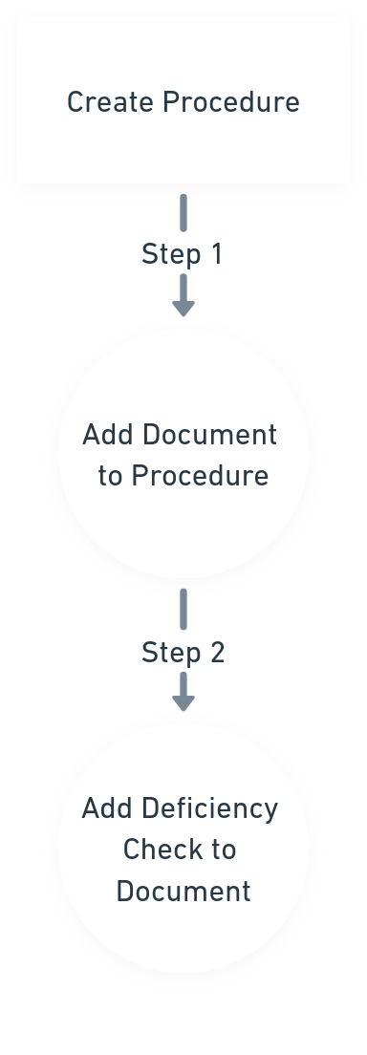  
     
   Conclusion:  
   This document provides a comprehensive guide for implementing a system to manage procedure metadata, including associated documents and their deficiency checks, using Spring Boot. By following these steps, you will create a robust backend system capable of onboarding procedures and ensuring that required documents meet specified criteria.  
     
     
   Mind Mapping :  
     
   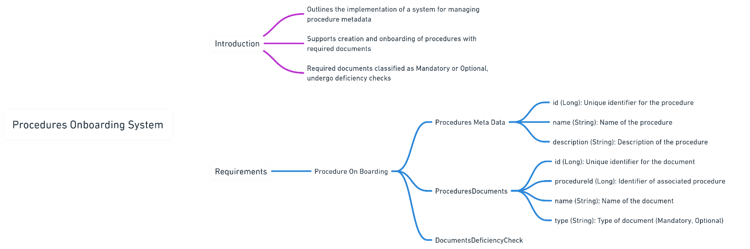  
     
   ER Diagram:  
   @Gaurav Sir  
   Need Suggestion   
     
   Should we differentiate 3 Meta Datas  
   1. Procedures.

2. Required Documents.  
3. Deficiency Checks.  
  
for example, Deficiency Check’s like -> is document has Patient Name on It.  
-> is document has Doctor’s Signature on It.  
  
like these the Deficiency Check is being repeated for all the documents most of the time.  
  
it will be easy in Front End at the time of Adding Deficiency Checks to the Required Document.